1)Create a database called person & create collection called details
2)Create the above 6 person’s details documents.
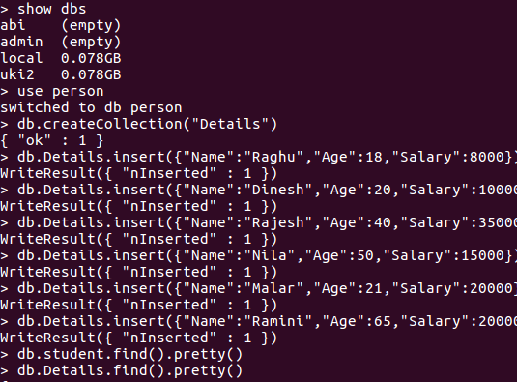

- Age > 50
- Age < 50
- Salary=20000/=
- Salary < = 20000/=
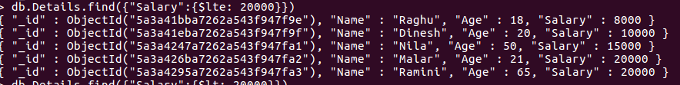
- Salary < 20000/=
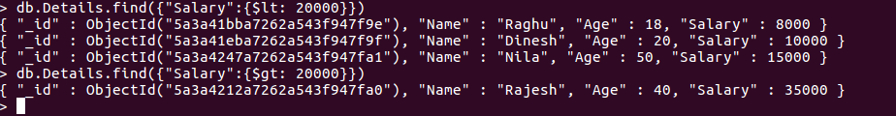
- Salary > 20000/=
- Age < 50 & Salary > 20000/=
- Age < 50 or Salary > 20000/=
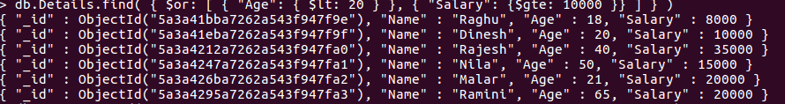
- Age < 20 or Salary >= 10000/=
- Age < = 20 and Salary >= 10000/=
